Instructions on how to use the Python and R files
Carefully extract files from the zipped folder, there are three files present in the zipped folder, (i)a jupyter notebook(containing two blocks of code) (ii) a Python file which has within it a python script (iii)An R file containing the Rscript that performs the same function that the python script does
The python script and the notebook both contain the same code, but the notebook is more explanatory and contains a lot of comments to explain each block of code
In the notebook there are two major broad cells that contain essentially the same code but the first cell only acts like a script while the second block prints out the result of the code in a CSV(comma separated values) file which can be viewed in excel or any sheet file application. The Rscript essentially also performs the same function as the python scripts

Instruction to run the python code
To run the python scripts you need to have a python IDE installed;pycharm, jupyter notebook, anaconda application or it can be run on the web using google colab
Using Notebook
Once the notebook is installed, the first diagram is the way it looks when the notebook is launched on the web, essentially it shows you folders and files present on your Local Computer
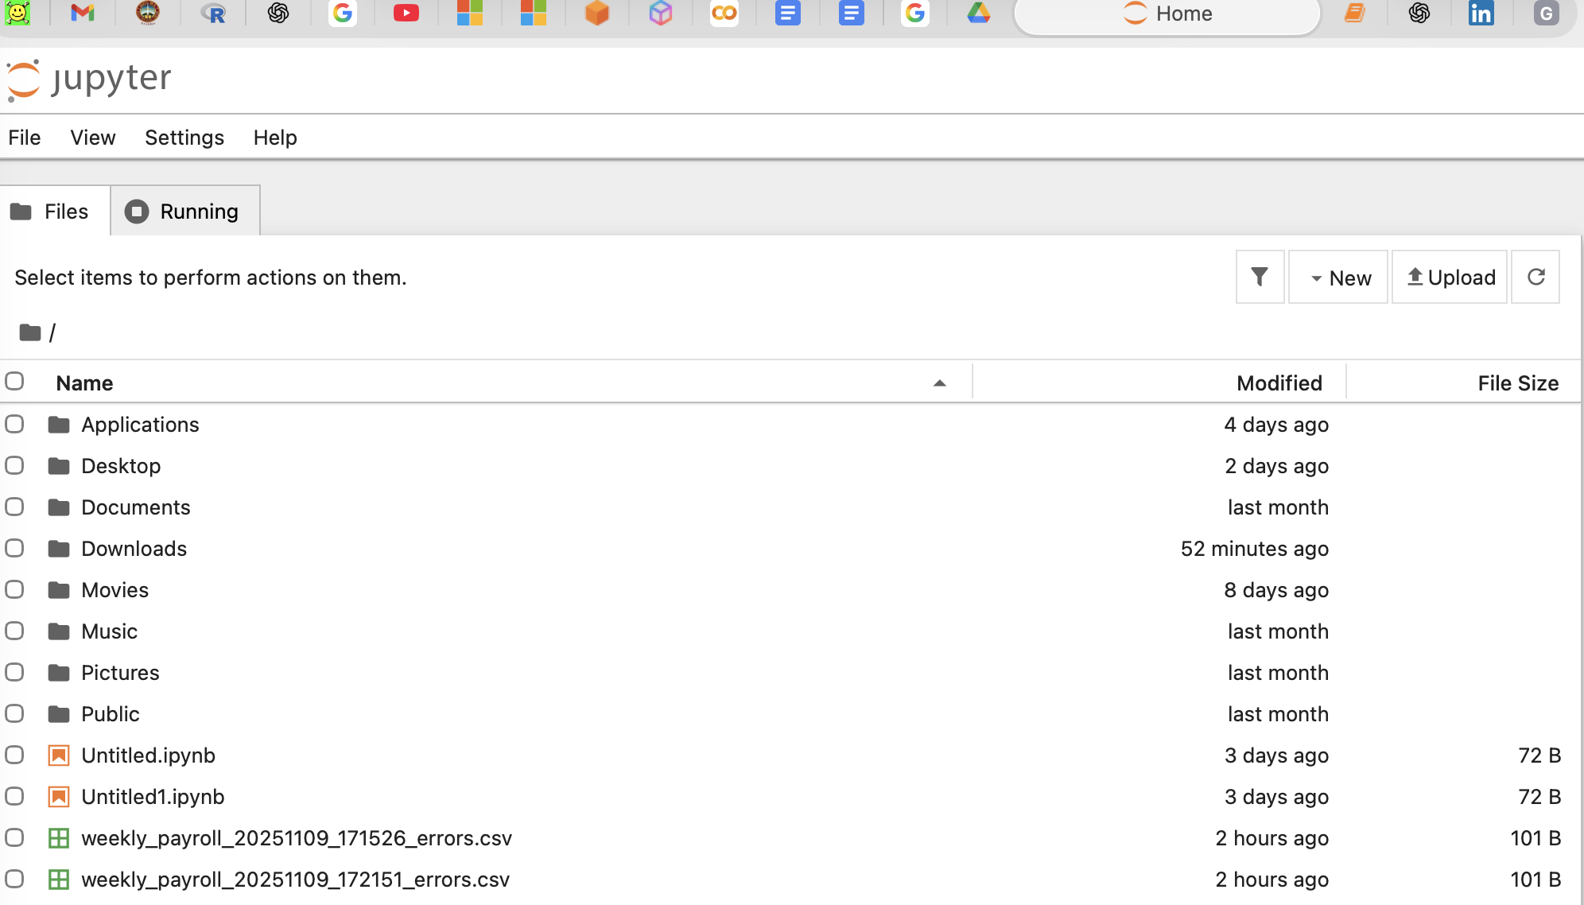

Then you can navigate to the file by clicking the desired folder which most likely is “download” if you downloaded the file from your browser
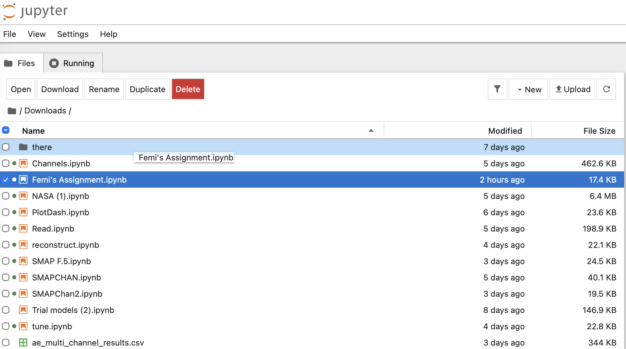

Once the file is identified simply click on it and another page would be open where you can run the file to see the results
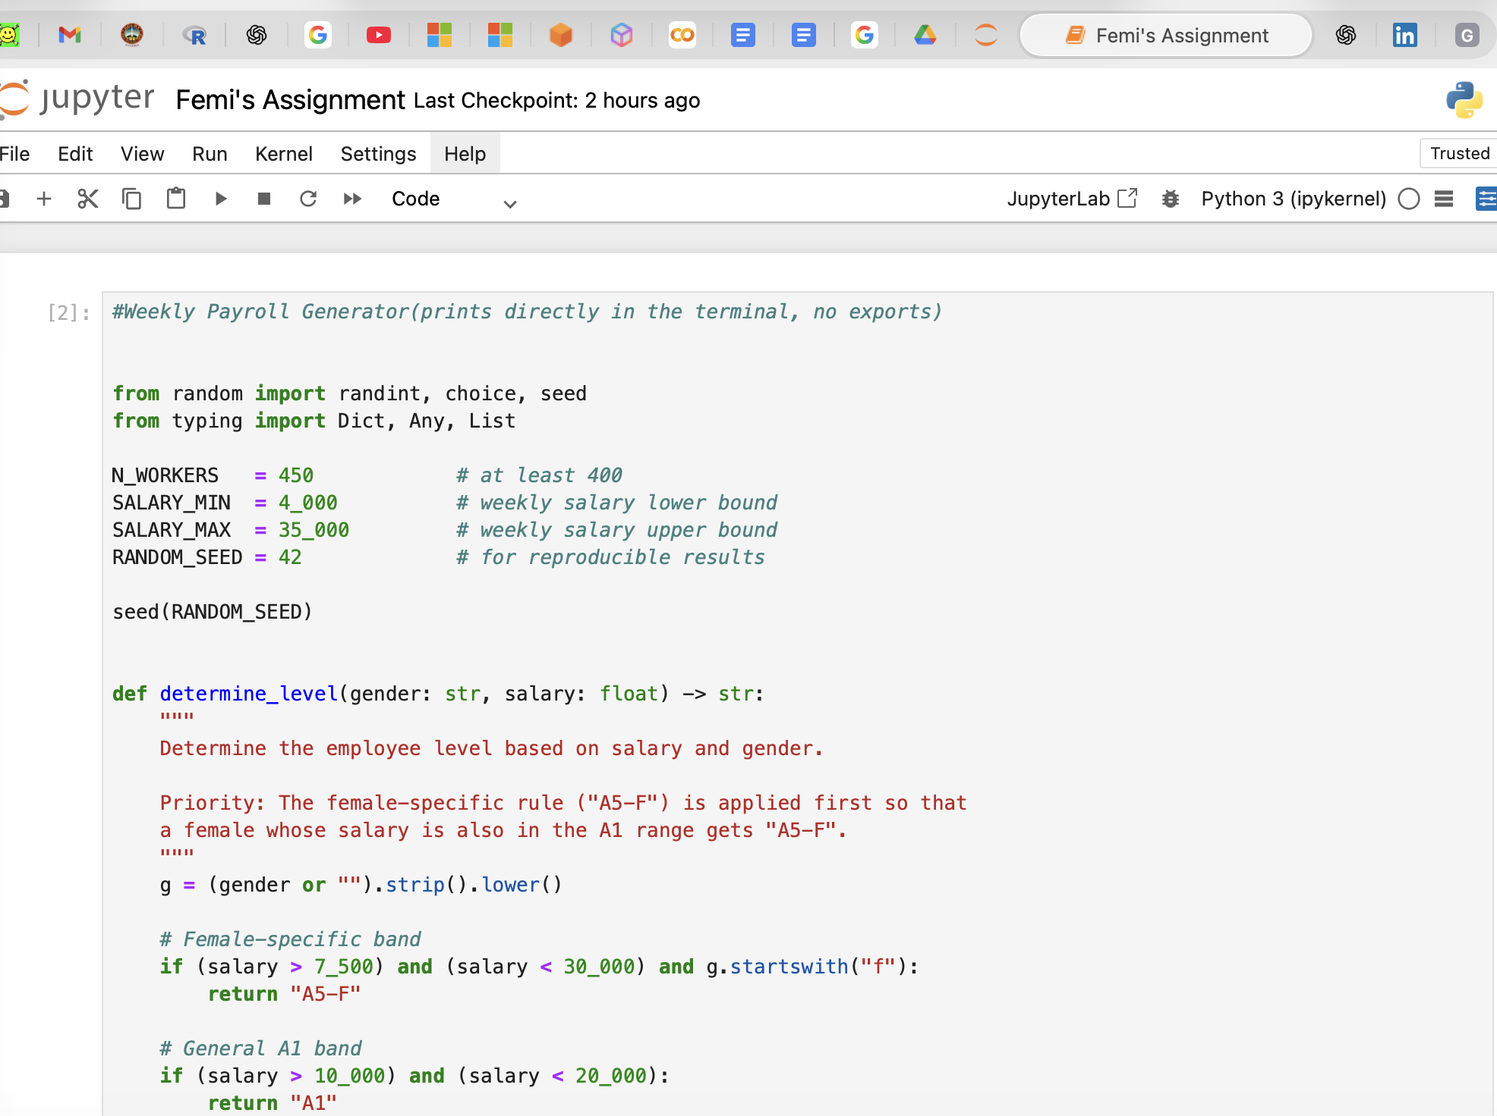
Click on the cell you want to run and then execute the code by clicking the play button in the ribbon above
To run on the web google colab
You can either copy the code and run directly in an cell on google colab or
First upload the downloaded and extracted ipynb file to a google drive, then open google colab in your browser and follow through with the following codes to connect the server to your drive the codes should look something like this
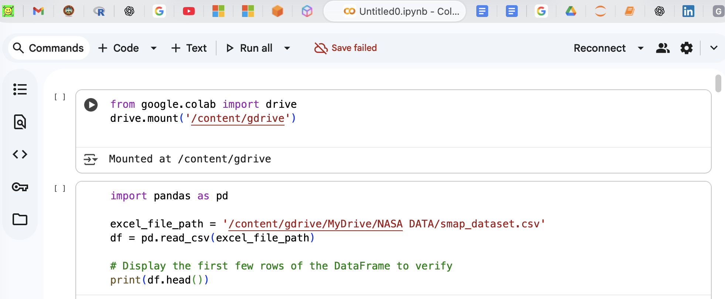
And by running the cells you should get your results below the cell same as in jupyter notebook 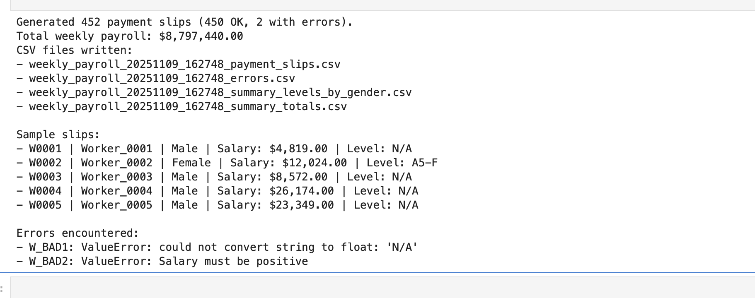

To run the R script
You should install Rstudio, using this website https://cran.rstudio.com/ from there just insert the code into the console, then press enter for it to run and the results should be displayed in the terminal by the right, like in the diagram below
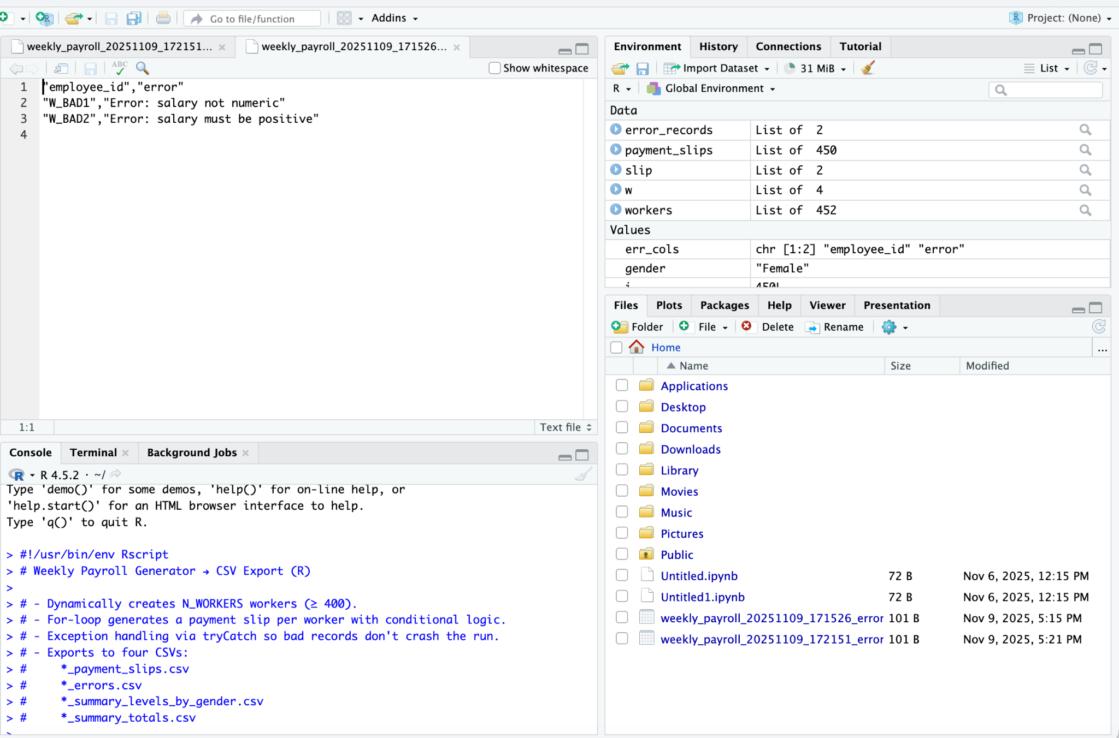

Comments are added within scripts to give explanation of what each block of code does.
With these instructions you should be able to run and deploy the codes in their various IDE environments.

